LAB 7 TASK 2

BAIYEWU AFOLAKE SIMBIAT

April 19, 2020

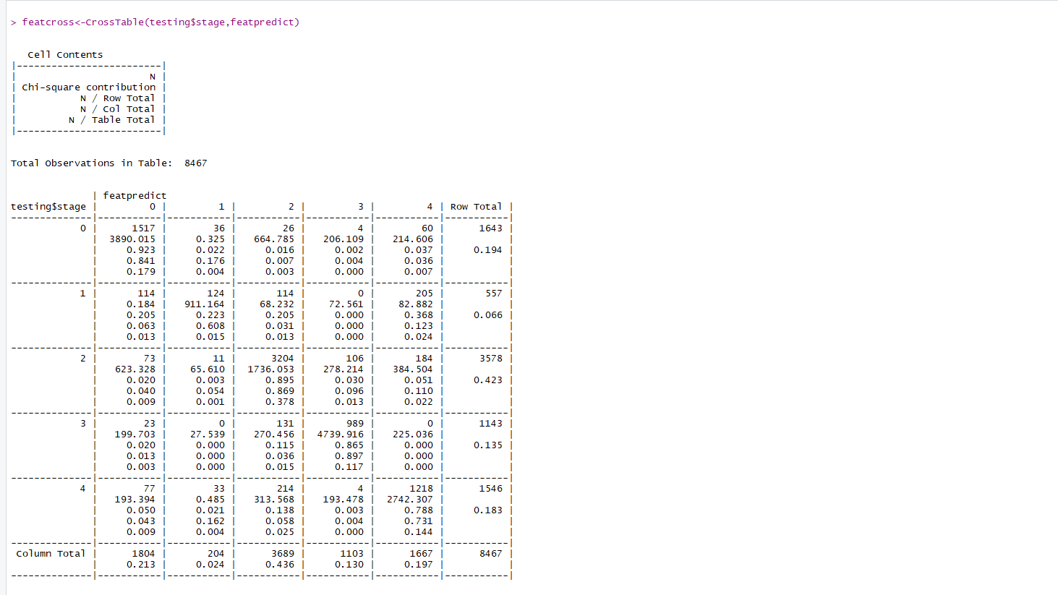

1. Cross table for feature and object

